**Area of a Circle**

Name ______________________________________________ Date _________________ Period _________

**Activity Background:** This activity will allow us to discover the formula for the area of a circle by building upon our knowledge of the area of rectangles.

**Materials:** Each person needs a circle resource page, 3 colors of pen/pencil/highlighter, glue, scissors and a blank paper.

**Steps:**

1) Use a color to mark the diameter of your circle. Write down the color here__________

2) Use a 2nd color to mark all the radii of your circle. Record the color here ___________

3) Use a 3rd color to mark the circumference of your circle. Record the color here _________

4) Cut out the circle from the resource page.

5) Cut the circle in half along the marked diameter.

6) For each semi-circle, carefully cut along the dotted lines from the center to about 1/2 cm from the edge (circumference). **Be sure not to cut the entire length of the radius.**

7) Open the two semi-circles and fit the “teeth” together. Glue the circle down so that the figure resembles a rectangle.

8) Without using a ruler, label the length and width of the rectangle. Consider from where in the circle each piece came. (Hint: Look at the colors!)

9) Using your knowledge of the area of a rectangle, find the area of this rectangle (the circle).

10) Will this work for any circle? Why or why not?

**Circle Resource Page**

**Formula for the Area of a Circle:**

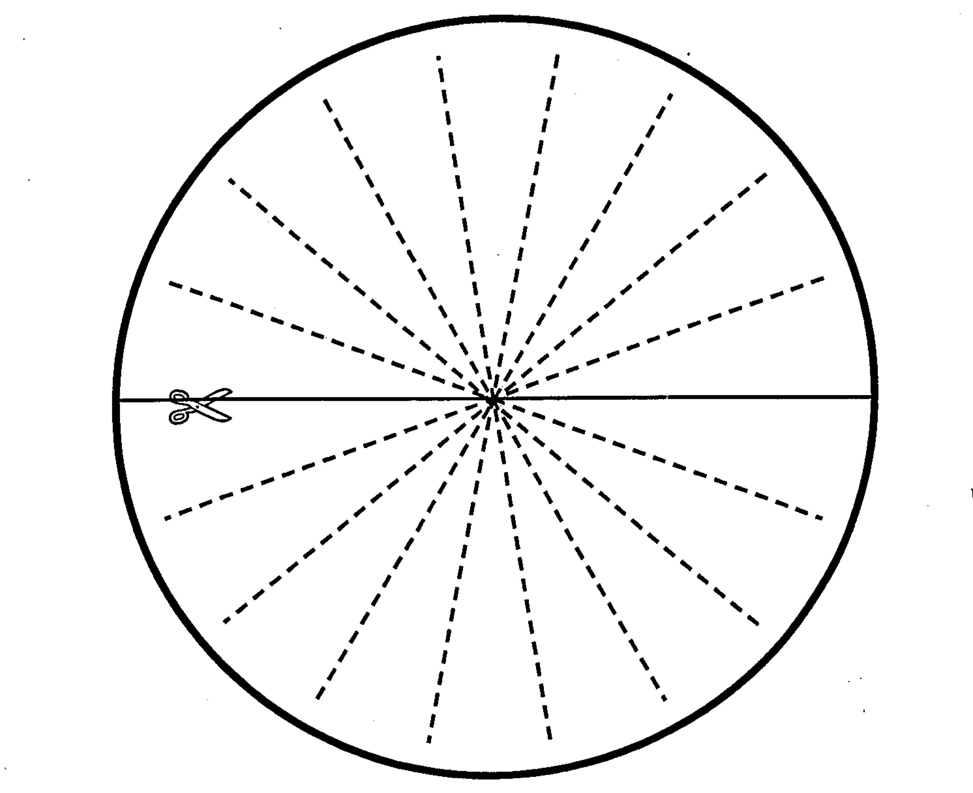

**Teacher Directions**

**Materials:**

Per Student:

Circle Resource Page (NOT copied on the back of the directions) and a few extra.

3 Colors per student (markers, highlighters or pens)

Scissors (1 per student)

Glue stick or tape (1 per student)

Blank or Construction Paper (1 per student)

Pass out page 1 to each student. Ask the students for which shapes they know how to find the area? (They should respond with at least rectangle and triangle). Explain that today you need to discover the formula for the area of a circle using what you know, so you will be making a circle fit into a rectangle.

Have a student read through the steps on the front page while you model what to do on the document camera. Once you are confident the students understand the directions, pass out the circle resource page, scissors, glue or tape and a blank paper or construction paper to each student.

Make sure the students color the circumference, diameter and radii and record those colors. When students cut along the radii towards the center, encourage them to leave a small space (if they cut through, they can still tape or glue it back or you can give them another circle page).

The finished product should look like this.



Once students are done with the gluing/taping, guide a class discussion to derive the formula for the area of the rectangle (a circle). Have the students COPY your steps onto their paper next to their taped rectangle.

1. Have each student write down the formula for the area of a rectangle (*b* x *h*).

2. Have each student label what the base and height are in terms of what they colored (base should be 1/2 circumference and height should be 1/2 diameter or radius).

3. Find the area: 

4. Now do some algebraic manipulation- ask the students what other way they know of to express *c*. ( or ). Substitute  for *c* to yield the following equation:

.

5. Simplify the equation to arrive at the Formula for the Area of a circle:

!