Skeletons & Skews
Name ______________________________________________ Date _________________ Period _________

Part 1: Intersection of Planes
Take three index cards and make a straight cut through the center, leaving about 1 inch un-cut.

Each index card represents a plane (a flat, 2-dimensional surface that extends in both directions forever).

Take two of your planes (index cards) and try to find some of the ways they could exist in the same space (intersecting and non-intersecting). Record at least two different intersections as pictures below and describe what the intersection is (e.g. a point, a line, no intersection, etc).

Repeat the same process, but now using 3 planes (index cards).
Record 2-3 possibilities as drawings below.

Part 2: Skeletons
Looking at a 3-D solid, use marshmallows and toothpicks or skewers to build replicas of two of the following solids:

Rectangular prism, Cube, Square-based pyramid, Triangular prism, Hexagonal prism.

Once you have built each solid, list the names of the faces and count and record the number of edges and vertices in the table below.

Table 1
Solid | Names of Faces | Number of Edges | Number of Vertices
Rectangular Prism

Cube

Square-Based Pyramid

Triangular Prism

Hexagonal Prism

Characteristics of the Solids: Below are 7 copies of your each solid. You need to find each of the following characteristics on the solids. Use color to show the characteristic or write “none” if your shape does not have this characteristic.

Parallel Lines |  | 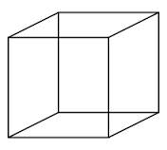 | 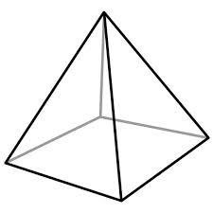 | 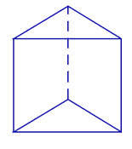 | 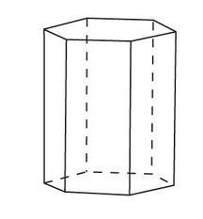
Parallel Planes

Perpendicular Lines

Perpendicular Planes

Intersecting Lines

Intersecting Planes

Skew Lines

Teacher Directions
Materials:
- Index Cards (3 per student)
- Scissors (1 per student)
- Geometric Solids (rectangular prisms, cubes, square-based pyramids, triangular prisms, hexagonal prisms)- 3-6 of each solid.
- Marshmallows (approx. 20 per student)
- Toothpicks (approximately 30 per student)
- Skewers or longer toothpicks (approximately 8 per student)
- Colored pencils or markers (1 pack per group)
Part 1: Intersection of Planes
Pass out the index cards and scissors to each student. Have the students cut straight across the center of the index card, leaving about 1 inch on the side.
Explain the definition of a plane, using the index card .
Ask the students to hold up two of the cards and show you how they might intersect or not (remind them that the “planes” go on in all directions forever). Instruct the students to “slide” one card into the other where they meet and ask what is formed by the intersection (a line). Give them a few minutes to explore and find all possible ways 2 planes can intersect or be parallel) and call on students to show different possibilities.
Repeat the same process for 3 planes (note you may want students to work with a partner when analyzing 3 planes).

Part 2: Skeletons
Give each student or pair of students a solid (choose from rectangular prisms, cubes, square-based pyramids, triangular prisms, hexagonal prisms).
Also give each student marshmallows, toothpicks and skewers or longer toothpicks. Tell the students they have 5 minutes to build their solid using the marshmallows and toothpicks.
Once the 5 minutes are up, have a discussion about the vocabulary used: the “planes” are the faces of each shape; the “marshmallows” are the vertices; and the toothpicks are the “edges”. Instruct the students to complete table 1 for their shape.

Do a quick survey of parallel, perpendicular and intersecting by asking students to use their arms to show you each of these terms. Hold up one of the solids or place it on the document camera. Point to a pair of parallel lines and ask the class to chorale respond what you would call those. Repeat this process for perpendicular lines, intersecting lines, parallel planes, perpendicular planes and finally intersecting planes (note that not all shapes have all of these). Finally, point to a set of skew lines (and/or show the picture from below), and ask students what they would categorize these as. Help them see the lines to do intersect but they are also not parallel, so they are called skew lines (a picture is shown for you below). Once students understand these terms, have them complete table 2, drawing their solid and using colors to show an example of each characteristic. Make sure they draw 1 large sketch and then use different colors to show an example of each characteristic.

Repeat the whole process for a second shape, if time allows. Students with good drawings should be able to use them for reference in the future, but if you prefer, have students make vocabulary cards with a definition, example, non-example and characteristics (Frayer model)

Finally have a discussion about how we name the solids. Those with parallel faces the same shape and rectangles connecting the faces are called “________ rectangular prisms” (with the blank being the name of the parallel bases.) A cube is a special type of a right rectangular prism as it has all squares for faces. The pyramid has a polygon base and triangular faces meeting at the apex.

Skew Lines (example):
