Slicing Play-doh
Name ______________________________________________ Date _________________ Period _________

Part 1: Right Rectangular Prism
Using your play-doh, build a right rectangular prism.
Using your dental floss or plastic knife, complete the following “slices”, each time recording a picture of both the 3-dimensional figure with the cut line and the 2-dimensional cross section. Then, re-build the rectangular prism to complete the next slice.

Ex: Slice perpendicular to the base.
3-D picture 2-D Cross Section Picture & Name
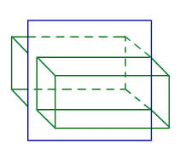
Rectangle

1. Slice Parallel to the base
3-D picture 2-D Cross Section Picture & Name

2. Diagonal Slice through a base
3-D picture 2-D Cross Section Picture & Name

3. Other Slice I discovered:
3-D picture 2-D Cross Section Picture & Name

Part 2: Triangular Prism
Using your play-doh, build a triangular prism.
Using your dental floss or plastic knife, complete the following “slices”, each time recording a picture of both the 3-dimensional figure with the cut line and the 2-dimensional cross section. Then, re-build the triangular prism to complete the next slice.

1.Slice perpendicular to the base.
3-D picture 2-D Cross Section Picture & Name

2. Slice Parallel to the base
3-D picture 2-D Cross Section Picture & Name

3. Diagonal Slice through a base
3-D picture 2-D Cross Section Picture & Name

4. Other Slice I discovered:
3-D picture 2-D Cross Section Picture & Name

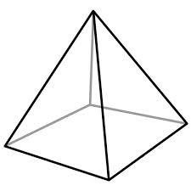
Part 3: Square-Based Pyramid
Using your play-doh, build a right square-based prism.
Using your dental floss or plastic knife, complete the following “slices”, each time recording a picture of both the 3-dimensional figure with the cut line and the 2-dimensional cross section. Then, re-build the square-based prism to complete the next slice.

1. Slice perpendicular to the base
3-D picture 2-D Cross Section Picture & Name

2. Slice Parallel to the base
3-D picture 2-D Cross Section Picture & Name

3. Diagonal Slice through the base
3-D picture 2-D Cross Section Picture & Name

4. Other Slice I discovered:
3-D picture 2-D Cross Section Picture & Name

Part 4: Conclusions
1. Look back at all the cuts you made that were perpendicular to the base. What was the shape of this cross-section? How does that relate to the faces of the solid?

2. Look back at all the cuts you made that were parallel to the base. What was the shape of this cross-section? How does that relate to the faces of the solid?

3. Look back at all the cuts you made that were diagonal through the base. What was the shape of this cross-section? How does that relate to the faces of the solid?

4. What other cuts did you find you were able to make? What types of cross-sections did those make?

Teacher Directions
Materials:
Play-doh (1 container per 2 students)
Plastic knife (1 per student) OR Dental Floss (approx. 1 foot per student)
3-D solids from for models (optional)- rectangular prism, triangular prism, square based pyramid.

Opening:
Ask students what a “cross section” is. Use think-pair-share to let them discuss. Then ask if they could dig a whole to get to the other side of the Earth. Have a few students explain. Then put up the picture of a cross-section of the Earth. Ask students why a cross-section is valuable and what it shows that we can’t see from the outside. Tell students today they will be examining cross-sections of 3-dimesional shapes.
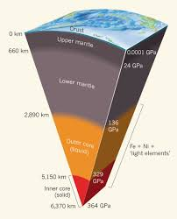

Part 1: Rectangular Prism
Pass out play-doh to each student and have them create a rectangular prism.
Then pass out dental floss or plastic knives to each student. Have everyone follow along with you as you slice your play-doh perpendicular to the base (see example on page 1). Have students slice their prism the same way and the ask them to show you the cross section and chorale state the name of this shape (rectangle). Show them how they would draw both the 3-D picture and draw and label the cross-section. Instruct them to re-build their rectangular prism and complete the next slice. Let students work alone or in pairs/groups and work at their own pace.
Once most students have completed part 1, select students to share their responses.
Note: for “other” cuts, encourage students to try cuts that do not go through the base.
Parts 2-3: Triangular Prism and Square-based Pyramid
Allow students to work at their own pace through parts 2 and 3, encouraging them to look for any different slices for each shape.
Part 4: Conclusions
If students have not completed the conclusions, then give them 5 minutes to do so independently followed by 2 minutes to share their results with their partner of group. Finally, check their understanding by having the class chorale response each question:
For Rectangular Prisms:
Perpendicular slices take the shape of lateral face.
Parallel slices take the shape of the base.
Diagonal slices create parallelograms.

For Triangular Prisms:
Perpendicular slices take the shape of lateral face.
Parallel slices take the shape of the base.
Diagonal slices create parallelograms or triangles.

For the Square-based Pyramid:
Perpendicular slices can be a triangle (if through apex) or a trapezoid, if anywhere else.
Parallel slices take the shape of the base.
Diagonal slices take the shape of a trapezoid or a triangle (if not through the base).

Optional:
Have students create a thinking map to summarize their findings.

