The Tower of Pisa

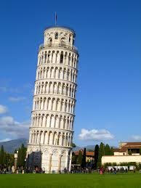
One of the seven Wonders of the World, the Tower of Pisa was built in Italy back in 1173 with marble. Not long after it was built, the ground under one side started to sink under the weight of the stones. Workers tried to compensate by making the columns on the other side slightly bigger to even out the lean. But that didn’t work.
The structure continued to decline into the 20th century, when engineers realized they had a problem. The tower was leaning more, about 1/20th of an inch every year, which would increase as the tower’s center of gravity shifted. Eventually, it would simply fall. That started a few different restoration efforts. One was to inject cement into the ground under the tower to stabilize it. That didn’t work so well, it just made the ground heavier, which made it subside more. Then engineers in the 1990s figured they needed to remove soil underneath the non-leaning side, inject more cement, and stabilize the structure with steel cables. Working delicately for about four years, they reduced the lean by 17 inches.

Now back to the physics: In terms of angles, the tower now leans at 3.99 degrees. Considering the weight and height of the tower, physicists have said the maximum angle would be 5.44 degrees before the tower falls (at its worst, the tower once leaned briefly at 5.5 degrees. Everyone is still baffled that it didn’t collapse).

Task: Using the picture above (or a sketch you draw), label where you think the following are:
A) the 3.99° angle at which the tower currently leans,
b) where the tower would be if it reached the maximum lean angle of 5.5°, and
c) where the 17 inches the lean was reduced by would be.
Be prepared to explain and defend your thinking.

Possible Solution
