Write the equation and solve for the unknown angle.

1)

2)

3)
4)
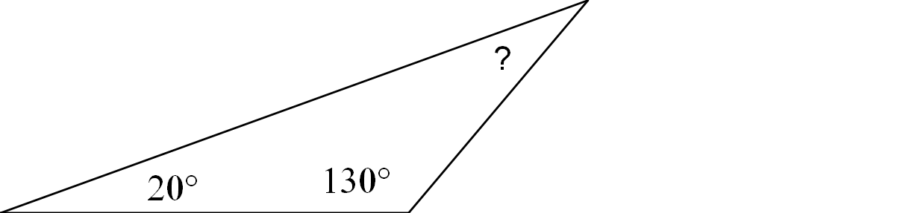
5)
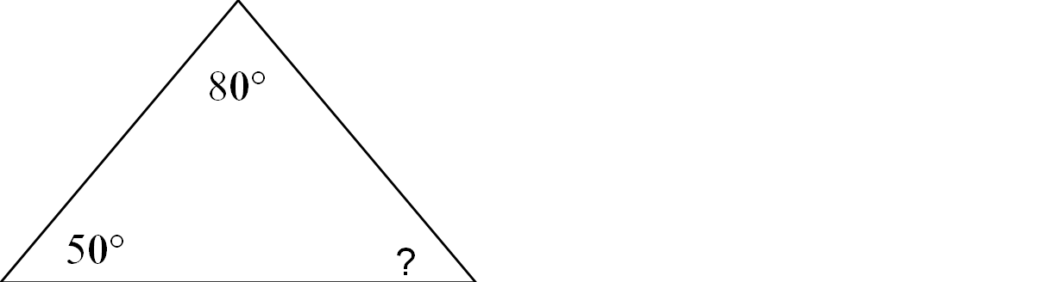

Write the equation and solve for the unknown angle.

6)
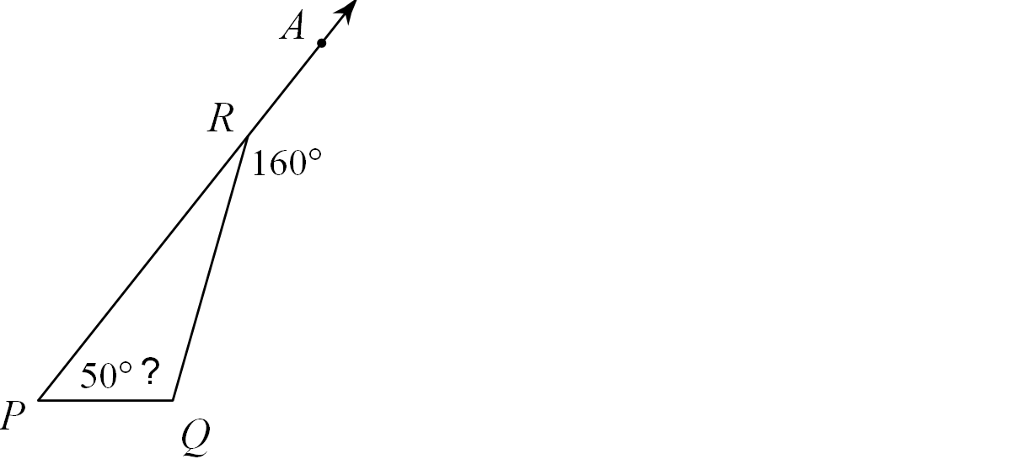

7)
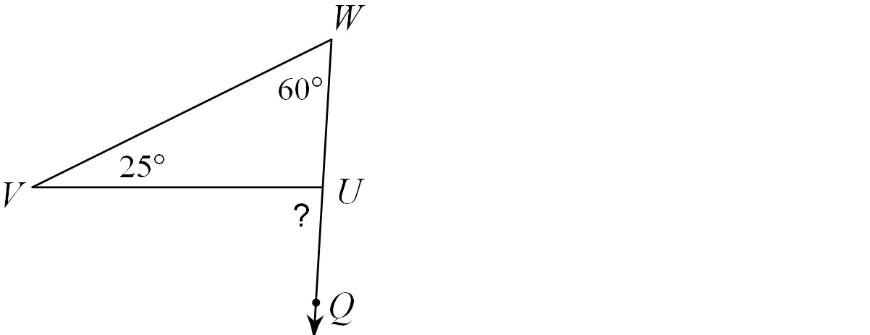

8)

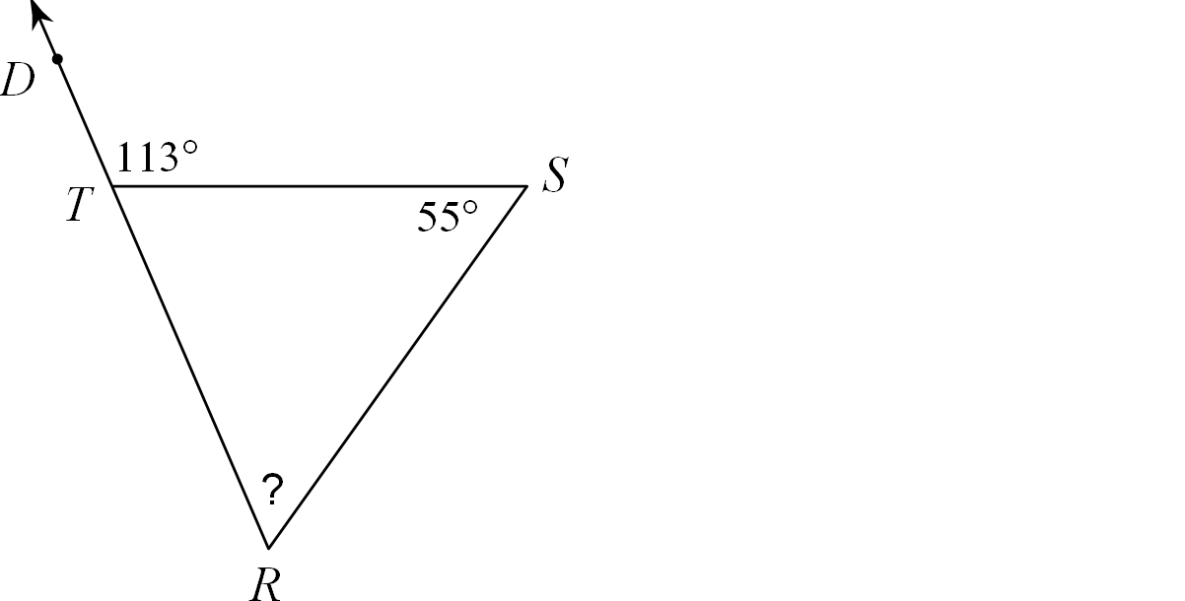

9)

10)
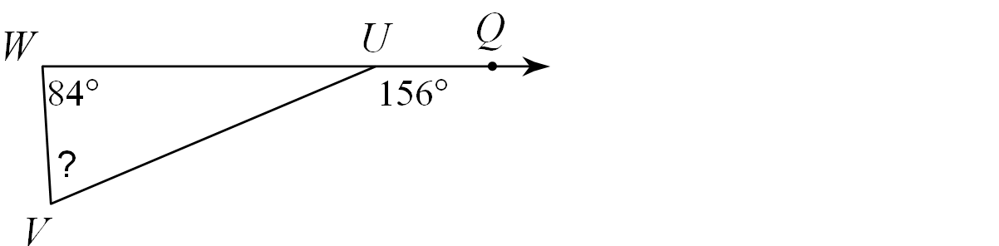
11) Angles M and N are supplementary. Angles M and N are congruent. What is the measurement of angle M?
12) Two angles of a triangle measure 30 and 50. What is the measure of the third angle of the third angle of the triangle?

