Sketch a picture for each problem. Set up an equation and solve it. Answer each question in a complete sentence.
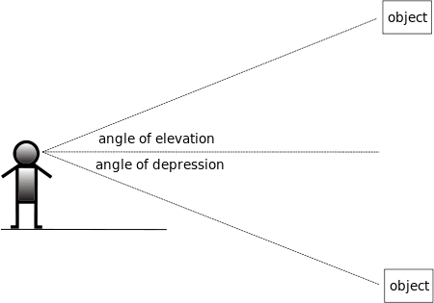 | The angle of elevation from the bottom of a waterslide to the platform above is 20°. If the waterslide is 25 meters long, how high is the platform?
You are on a salvage ship in the Gulf of Mexico. Your sonar system has located a sunken Spanish galleon at a slant distance of 680 meters from your ship, with an angle of depression of 31°. How deep is the water at the galleon’s location? How far must you sail to be directly above the galleon? | An observer 5.2 kilometers from the launch pad observes a missile ascending. At a particular, the angle of elevation is 37.6°. How high is the missile?
You lean a ladder 6.7 meters long against the wall. It makes an angle of 63 degrees with the level ground.  How high up is the top of the ladder? | You are standing halfway between two trees that are 40 feet apart. The angles of elevation from your feet to the tops of the trees are 42º and 38º. How much taller is one tree than the other? (hint: find the height of each tree separately).

