**Toothpick Patterns**

**Task 1:**

Build the following pattern with your toothpicks. Study the pattern and then build and draw figures 4 and 5. Use the information to complete the table at the bottom.

**Pattern A**

1.

2.

3.

4.

5.

|  |  |
| --- | --- |
| **Figure Number** | **Number of Toothpicks** |
| 1 |  |
| 2 |  |
| 3 |  |
| 4 |  |
| 5 |  |
| 6 |  |
| 10 |  |
| *n* |  |

**Task 2:**

Build the following pattern with your toothpicks. Study the pattern and then build and draw figures 4 and 5. Use the information to complete the table at the bottom.

**Pattern B**

1.

2.

3.

4.

5.

|  |  |
| --- | --- |
| **Figure Number** | **Number of Toothpicks** |
| 1 |  |
| 2 |  |
| 3 |  |
| 4 |  |
| 5 |  |
| 6 |  |
| 10 |  |
| *n* |  |

**Pattern C**

1.

2.

3.

4.

5.

|  |  |
| --- | --- |
| **Figure Number** | **Number of Toothpicks** |
| 1 |  |
| 2 |  |
| 3 |  |
| 4 |  |
| 5 |  |
| 6 |  |
| 10 |  |
| *n* |  |

**Task 3:**

Using the graph below, graph the coordinates from each of your tables (as many as fit). Use one color for the graph of pattern A, another color for the graph of Pattern B, and a 3rd color for pattern Pattern C.

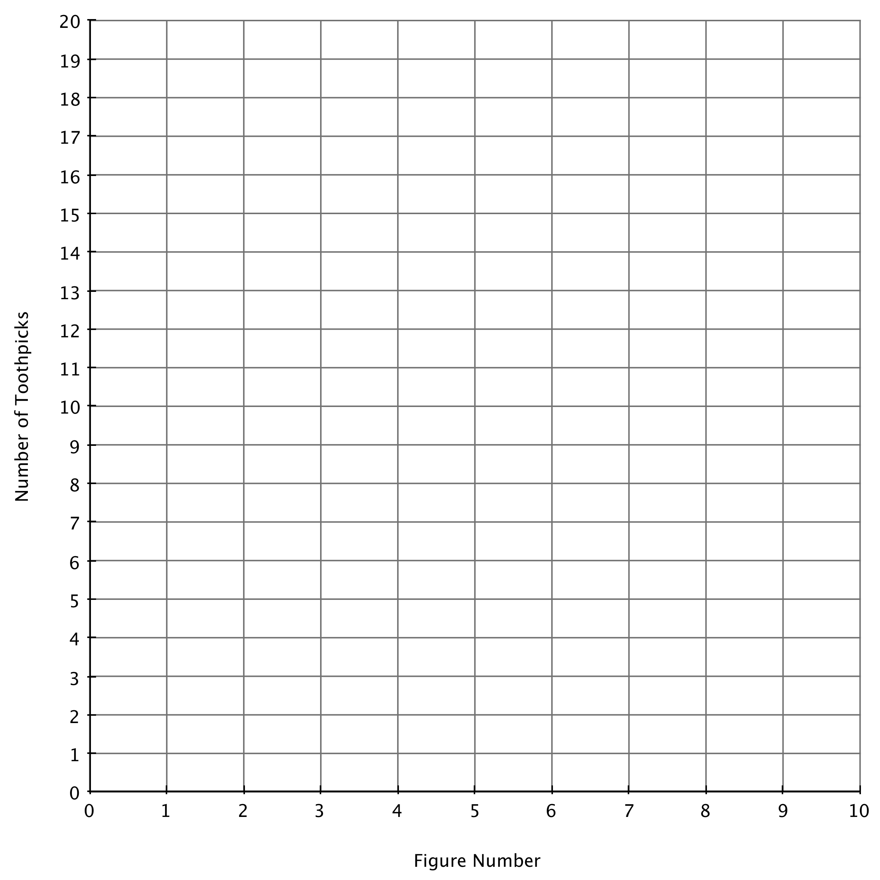

**Task 4: Analysis Questions**

1) How are patterns A, B, & C growing (what do you add to get from one figure to the next)? Where does this growth show up on the tables?

2) What is the same about the three graphed lines, equations, and how the pattern grows?

3) What is different about the three graphed lines & equations? Where do see the differences on the graph?

4) If you were to draw figure 0 for each pattern (go back one step), how many toothpicks would there be? Where do you see this number on your graph? Where do you see this number in the equation?

5) What, in a pattern, determines where its graph will cross the y-axis? Where does this number show up in the equation?

6) If the equation of a new pattern were *y*= 3*n* + 10, what do you think the pattern would look like? Use the grid in task 3 to graph *y*= 3*n* + 10.