**Cups & Stacks**

**Part A Directions:**

Complete the table & graph your data after measuring the height of 1, 2, then 3 cups at your desk using centimeters. Use what you learned in Nuts & Bolts, Toothpicks, and Pattern Relay to generate an expression for *c*.

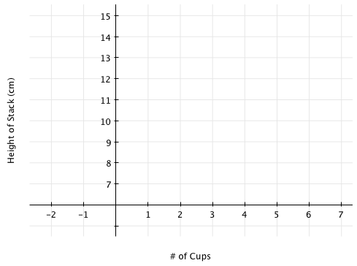

|  |  |
| --- | --- |
| ***c***  **# of cups** | ***h***  **height of stack** |
| 0 |  |
| 1 |  |
| 2 |  |
| 3 |  |
| 4 |  |
| 5 |  |
| 6 |  |
| ***c*** |  |

**Part B**:

1. a) How did you find the remaining points without cups to measure? Explain.

b) What is the slope of the equation? What does it mean in terms of cups?

1. a) How did you find the general expression (using *c* and *h*) in the last row of your table. Explain.

b) What is the *y*-intercept of the equation? What does it mean in terms of cups? Draw a picture to explain.

1. Find the height of a stack of 10 cups. List two ways in which to find the answer.

Method #1:

Method #2:

1. Draw a picture of a stack of cups with the equation *h* = 2*c* + 8. Label your picture, then complete the fill in the blank.
   1. The slope of my function is _______ meaning when I add one cup to the stack, my stack increases in height by______cm.
   2. The *y*-intercept of my graph is ____ meaning the line crosses the _____ axis at (___,____).
2. Does the height for zero cups make sense? What part of the cup does the height of zero measure? Draw a picture to explain.