Slope Triangles Inside

Definitions
The slope of a line is the ratio:
This is assigned the letter “m”. (Don’t forget to simplify!)

Example 1
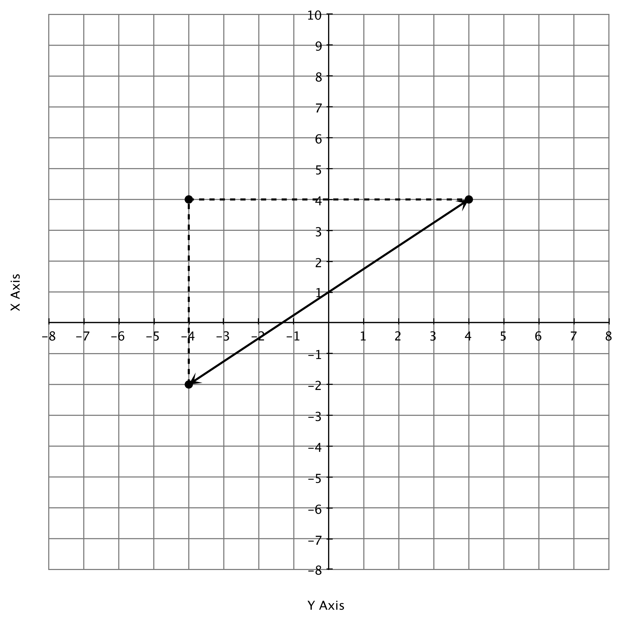

m =

8
8

6
6

Example 2
Always check to see if you have the sign for the slope correct by writing or imagining the word slope written on your line. If the word is going uphill, the sign should be positive, if the word is going downhill, the sign for the slope should be negative.

Using the directions above, write the word “slope” on the line, and then determine whether the slope of the line is positive or negative.
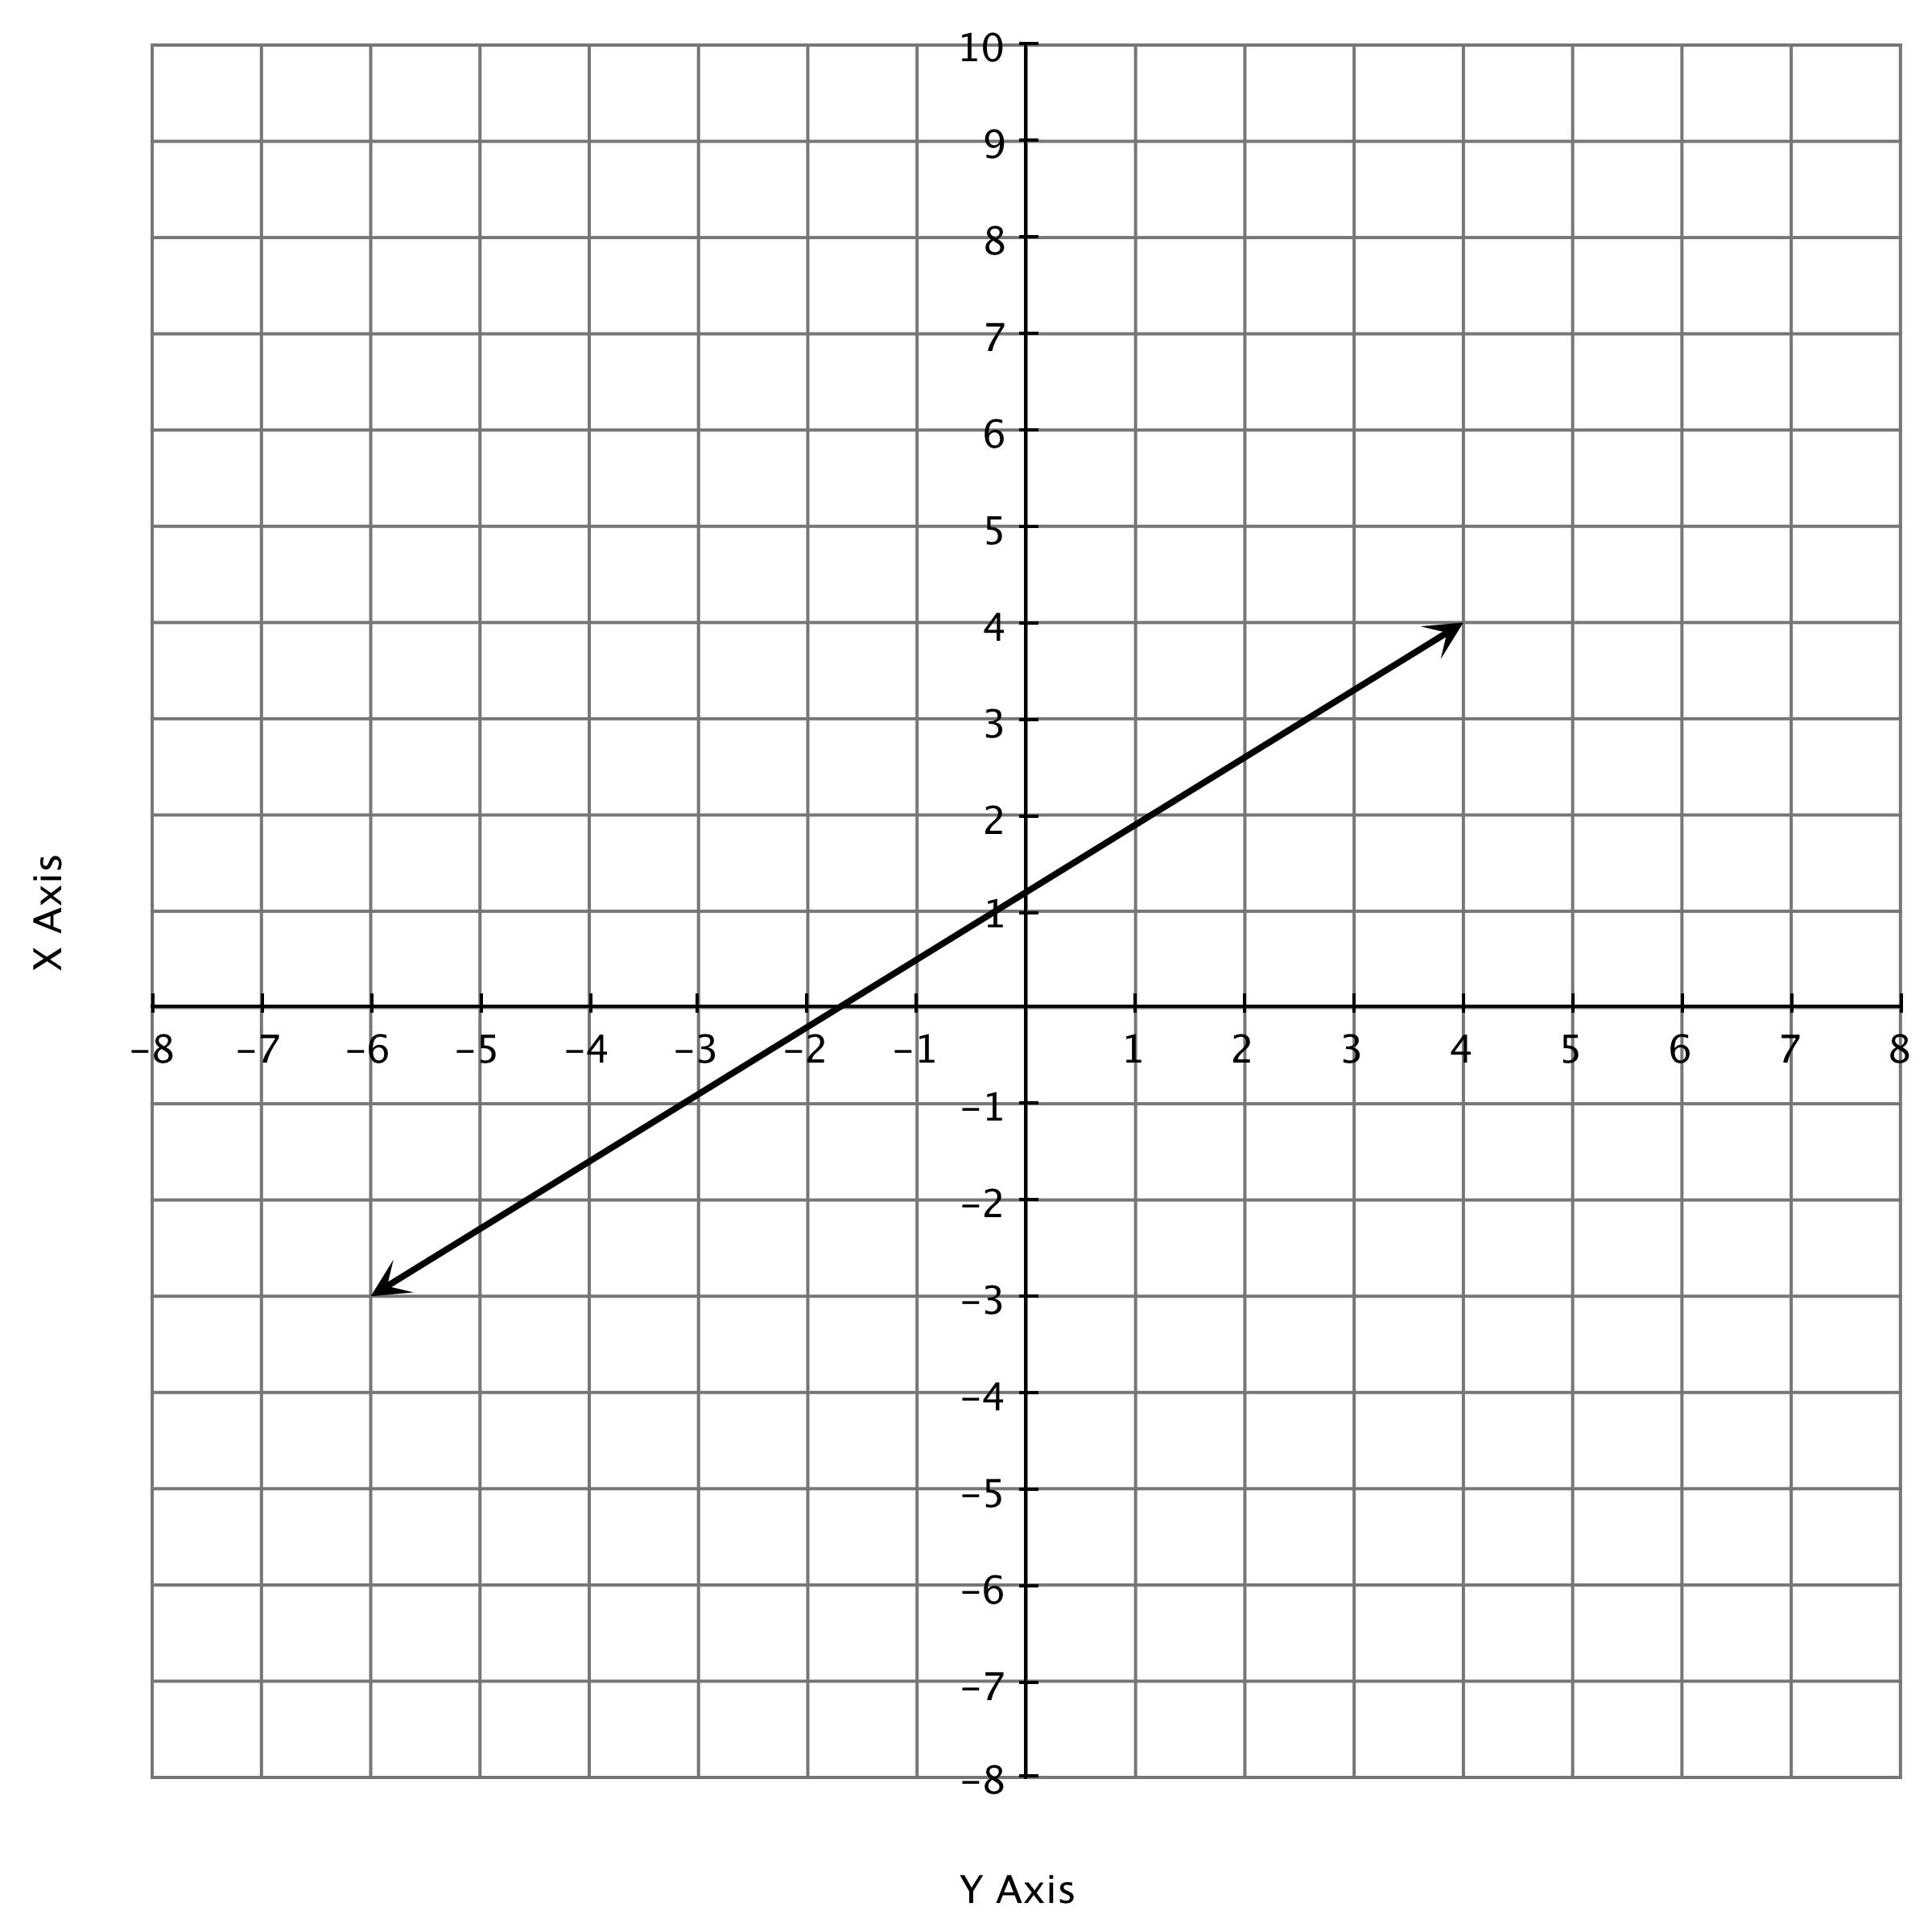
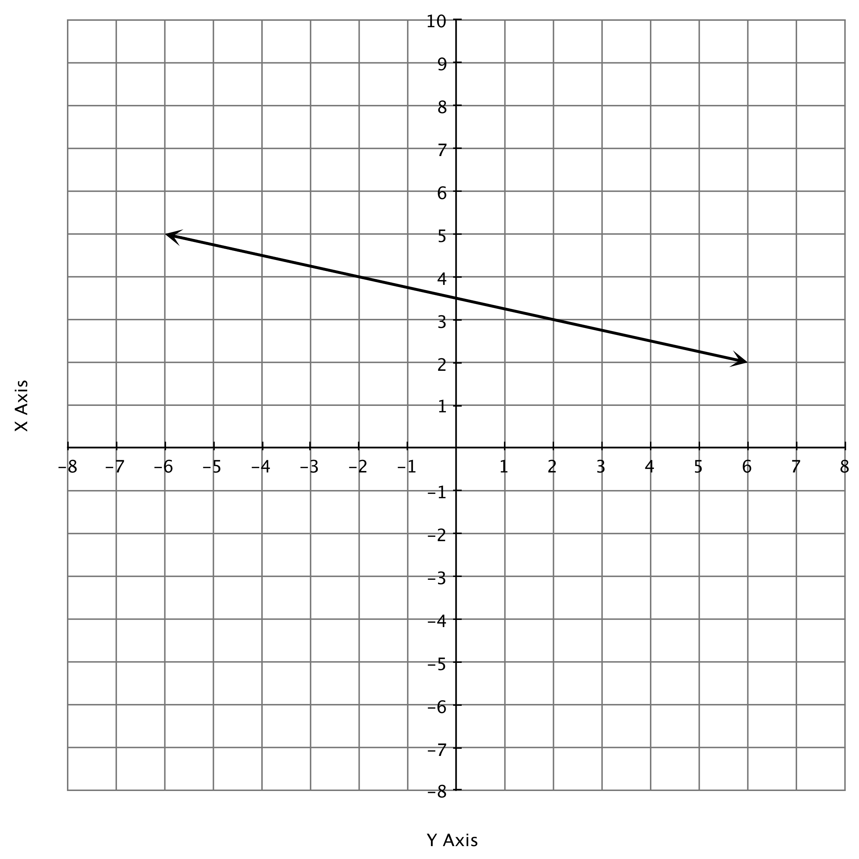

Part I Directions: Find the slope for each graph.
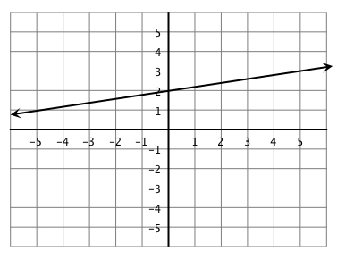
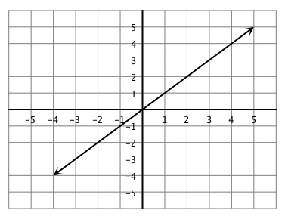
1. 2.

m = m =

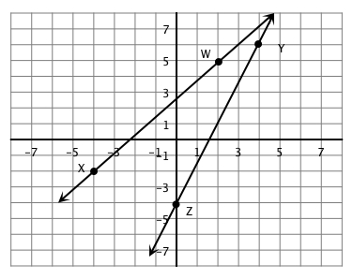
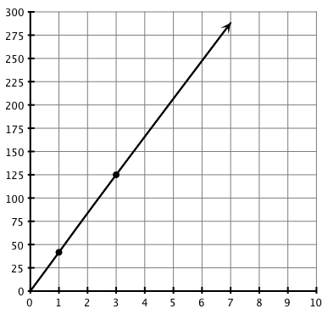
3. 4.
Slope of =

Slope of =

Which line is steeper?

Explain your answer.
m =

5)

m =

0
y
0
x
5
-4
-2
1
3
-5
-5
-3
-1
2
4
-5
-3
2
5
-2
3
-5
4
1
-1
5
-4
6)

m =
0
y
0
x
5
-4
-2
1
3
-5
-5
-3
-1
2
4
-5
-3
2
5
-2
3
-5
4
1
-1
5
-4

Part 2: Some interesting slopes.
Find the slope of each of the lines below.
7)

m =
0
y
0
x
5
-4
-2
1
3
-5
-5
-3
-1
2
4
-5
-3
2
5
-2
3
-5
4
1
-1
5
-4
8)

m =
0
y
0
x
5
-4
-2
1
3
-5
-5
-3
-1
2
4
-5
-3
2
5
-2
3
-5
4
1
-1
5
-4

Part 3: Watch out for the scaling!!!
Find the slope of each of the lines below, paying particular attention to how much each unit (space) represents!
9)

m =
0
y
0
x
15
-12
-6
3
9
-30
-30
-20
-10
5
15
25
-15
-9
6
30
-15
10
30
-3
-25
20
12
-15
-5
10)

m =
0
y
0
x
50
-40
-20
10
30
-100
-100
-60
-20
40
80
-50
-30
20
100
-40
60
-50
40
20
-10
100
-80

Part 4: Graph and Count
Plot each of the points listed and then draw a slope triangle to find the slope between the two points.

11) Find the slope of the line passing through points (-2,4) and (3,6)

m =
m =
y
x
6
-4
2
6
6
-4
2
6
-6
4
-6
4
-2
-2
-6
-6
12) Find the slope of the line passing through points the points (2,4) and (-2,-4)

m =

y
x
6
-4
2
6
6
-4
2
6
-6
4
-6
4
-2
-2
-6
-6

13) Find the slope of the line passing through points (0,5) and (4,5)

m =

y
x
6
-4
2
6
6
-4
2
6
-6
4
-6
4
-2
-2
-6
-6
14) Find the slope of the line passing through the points (2,-5) and (-4,1)

m =

y
x
6
-4
2
6
6
-4
2
6
-6
4
-6
4
-2
-2
-6
-6

