Name __________________________ Date _____________ Period _______
Triangle Exploration: adapted from Mathalicous.com

Widescreen TVs like the one below have an aspect ratio of 16:9. Based on this:

TV 1: TV 2:

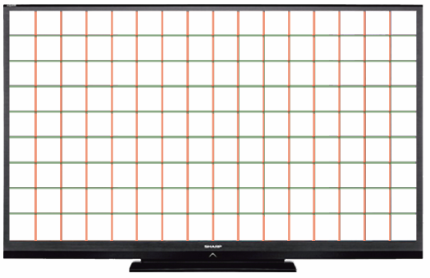

1a. If the screen of TV 1 is 40 inches wide, how tall must it be? | 1b. If the screen of TV2 is 40 inches tall, how wide must it be?

2. Draw in one diagonal for each of the tv’s above.

3. What type of triangles do you create when you do this? Justify your answer.

FACT: The size of a TV screen is measured diagonally, for instance, a 55-inch TV is 55 inches from corner to corner.

4. Based on the lengths of your sides what do you predict is the size of TV1 and TV2? Justify your answer.

FACT: You can find the exact size of the tv using the following formula:
Size of TV = $\sqrt{{\left(width\right)}^{2}+{\left(height\right)}^{2}}$

5a) Use the formula above to find the exact size of TV 1. Then sketch a picture of the tv with the width, length and diagonal labeled. | 5b) Use the formula above to find the exact size of TV 2. Then sketch a picture of the tv with the width, length and diagonal labeled.

FACT: 16:9(widescreen) isn’t the only aspect ratio. Televisions also come in 4:3(standard) and 21:9(cinema).

6) Using what you have learned so far, what is the size of a (standard) television that has a width of 40 inches. Sketch a picture of the tv with the width, length and diagonal labeled. | 7) Using what you have learned so far, what is the size of a (cinema) television that has a width of 40 inches. Sketch a picture of the tv with the width, length and diagonal labeled.

8) Which tv is largest from problem 5a, 6, and 7, based on the size of the tv screen?

