Puppy Weights
Name ____________________________________________ Date __________ Period __________

(Lesson adapted from Illustrative Mathematics)

Below is a dot plot of 25 birth weights, in ounces, of Labrador Retriever puppies born at a kennel in the last 6 months.
1) Create a 5-Number Summary of the Data represented in the dot plot.

- Median ______________
- Q1 ____________
- Q3 ____________
- Minimum Value __________
- Maximum Value __________
 |  |  |  |  | X
 |  |  |  | X | X
 |  |  |  | X | X
 |  |  |  | X | X
 |  |  | X | X | X
 |  |  | X | X | X
 |  | X | X | X | X
X | X | X | X | X | X | X | X
13 | 14 | 15 | 16 | 17 | 18 | 19 | 20
Birth Weight in Ounces
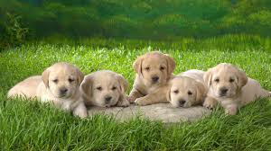

2) Using your 5-Number Summary, construct a box-and-whisker plot.

Answer the following questions about the data using your box-and-whisker plot.
3) How does the shape of the box-and-whisker plot compare with the dot plot in terms of distribution of puppy weight? (How is it skewed?)

4) What is the interquartile range? ________________ What does this value tell us about the puppy weights?

5) What is a typical birth weight for puppies born at this kennel in the last six months? Explain why you chose this value.

6) Find the mean weight for the puppies. ________________ How does this value compare to the median weight? Is this weight surprising? Why or why not?

7) Are there any outliers? Explain.

8) How would the box-and-whisker plot change if we excluded the 13-ounce puppy from our data?

9) Find the mean absolute deviation (MAD). What does this tell you about the variability of the puppy weights?

MAD = ___________

Teacher Directions: Puppy Weights
Materials:
- Copies of Puppy Weights Worksheet (1 per student)

Opening Question
This is meant to be a review of the material learned. Place the following question and image on the board. Instruct students that this is a think-write-pair-share question where they will have 2-minutes to silently think and write about the scores in the two classes shown below.

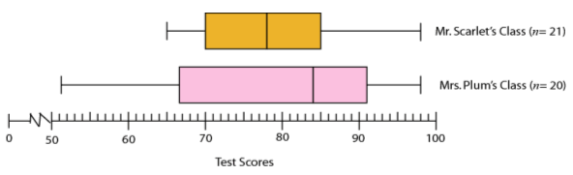

Write down as many things as you can comparing and contrasting the test scores in Mr. Scarlet’s class with the scores in Mrs. Plum’s class.

Once two-minutes have passed, have students share their list with an elbow partner. Give students 2-3 minutes to discuss. Once 2-3 minutes have passed, ask for volunteers to explain how the classes are alike and how they are different. Record all student answers on the board, and discuss any items that might illustrate misconceptions.

Ask students the following questions if they were not discussed:
- Which class has the greater median score?
- Which class has the highest score? What is it?
- Which class has the lowest score? What is it?
- How are Mr. Scarlet’s class scores distributed?
- How are Mrs. Plum’s class scores distributed?
- Which class had the greatest variability (spread)?
- Which class performed better on the test? Why?

Puppy Weights
- Pass out activity sheet, Puppy Weights and have a volunteer read the opening statement.
- Have students create a 5-Number Summary of the data represented by the dot plot. After 5 minutes, have students share their results. Once the class agrees on the answers, have students construct a box –and-whisker plot.

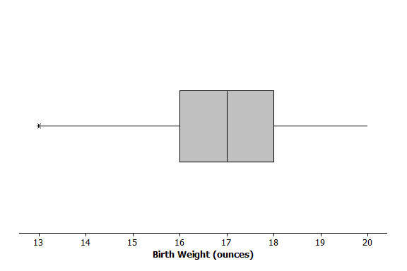
- Answers
  - Median = 17 ounces
  - Q1 = 16 ounces
  - Q3 = 18 ounces
  - Minimum Value = 13 ounces
  - Maximum Value = 20 ounces

- Walk around and monitor students as they are constructing their box-and-whisker plots. When most of the class has finished, ask for a student volunteer to come up and present their plot. Use thumbs up/down to ask students if they agree or disagree with the box-and-whisker plot shown. If students agree or disagree, ask them to explain why.

- Give students another 10-minutes to answer questions 3 through 8. Once 10 minutes has passed, have students share their answers. If time permits, have students construct another 5-Number Summary and box-and-whisker plot for question 8, excluding the 13-ounce puppy. Ask students if their box-and-whisker matched their original answer to question 8.

- Question 9 is a review of finding MAD. Have students find the MAD value and then compare with a neighbor. Then ask them to complete the question about what this value tells them in terms of puppy weights.

