**Unit Rate**

**Directions:** For each scenario, the ratio(s) are listed in the table as well as some additional numbers. Complete the rest of each ratio table and list the Unit Rate (a Ratio with a denominator of 1). Then try to come up with other methods to calculate how much “1” of something is and record this as the unit rate.

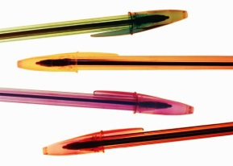1. At the office supply store, a 16-pack of pens cost $8.

|  |  |  |  |  |
| --- | --- | --- | --- | --- |
| **Number of Pens** |  |  |  | 16 |
| **Cost ($)** | 1 | 2 | 4 | $8 |

Unit Rate 1: Pens per dollar:

|  |  |  |  |  |  |
| --- | --- | --- | --- | --- | --- |
| **Cost ($)** |  |  |  |  | $8 |
| **Number of Pens** | 1 | 2 | 4 | 8 | 16 |

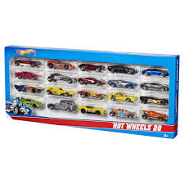

Unit Rate 2: Cost per pen:

2. A 9-pack of cars costs $8.50

|  |  |  |  |
| --- | --- | --- | --- |
| **Cost ($)** |  |  | $8.50 |
| **Number of Cars** | 1 | 3 | 9 |

Unit Rate: Cost per car:

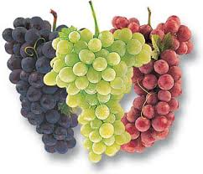3. At the grocery store, the special on grapes is 3 pounds for $2.99.

|  |  |  |
| --- | --- | --- |
| **Cost ($)** |  | $2.99 |
| **Pounds of grapes** | 1 | 3 |

Unit Rate: Cost per pound:

4. Betsy ran a mile and then checked her heart rate. After 30 seconds, she had counted 64 beats.

|  |  |  |  |
| --- | --- | --- | --- |
| **Beats** |  |  | 64 |
| **Seconds** | 1 | 15 | 30 |

Unit Rate: Beats per second:

Complete the second table to find Beats per MINUTE (60 seconds)

|  |  |  |  |  |
| --- | --- | --- | --- | --- |
| **Beats** |  |  | 64 |  |
| **Seconds** | 1 | 15 | 30 | 60 |

Unit Rate: Beats per minute:

**Summarizing methods:**

Go back to the 4 problems and list, in the table provided, the original ratio and the unit rate. The first one is done for you.

|  |  |  |
| --- | --- | --- |
| **Problem #** | **Original Ratio** | **Unit Rate** |
| 1- pens per dollar |  |  |
| 1- cost per pen |  |  |
| 2- cost per car |  |  |
| 3- cost per pound |  |  |
| 4- beats per second |  |  |
| 5- beats per minute |  |  |

Study each row in the table and come up with a method by which you could calculate a unit rate if you only had the original ratio. Explain your method below and give an example.

_______________________________________________________________________________________________

_______________________________________________________________________________________________

_______________________________________________________________________________________________

Try to come up with a second method you could use and record that (or an idea you hear from a classmate) below.

_______________________________________________________________________________________________

_______________________________________________________________________________________________

_______________________________________________________________________________________________

**Applying Methods**

Using any method you prefer, calculate the unit rate for each problem below. Make sure to show your thinking and be prepared to explain to the class.

1. Matthew ran 20 feet in 5 seconds.

Unit Rate (feet per second):

2. Chips are on sale $4.50 for 12 ounces.

Unit Rate (price per ounce):

3. A motorcycle travels 340 miles on 4 gallons of gas.

Unit Rate (miles per gallon):



4. cups of flour for every cups of sugar.

Unit Rate (Cups of sugar per cup of flour):

5. 15 pesos for $3.50.

Unit Rate (Peso per dollar):