Math 2: Volume of Cones Name ___________________________
Date ___________________ Per _____

1. The part of a dish designed for ice cream is shaped like an upside-down cone. The base of the cone has a radius of 2 inches and the height is 1.2 inches. What is the volume of the cone? Round your answer to the nearest hundredth.

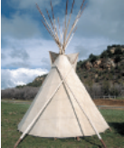
2. The covering on a teepee rests on poles that come together like concurrent lines. The resulting structure approximates a cone. If the teepee pictured is 12 ft. high with a base diameter 14 ft., find its volume.

3. In a chemistry lab you use a ﬁlter paper cone to ﬁlter a liquid. The diameter of the cone is 6.5 cm and its height is 6 cm. How much liquid will the cone hold when it is full?

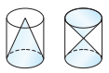
4. CHALLENGE: The two cylinders pictured below are the exact same size. How does the volume of the larger cone compare to the total volume of the two smaller cones? Explain.
5 in
8 in
8 in

