** What Relationship do you See?**

**Part 1:** For each graph below, look at the data and then describe what relationship(s) you see. Be prepared to share your ideas with the class.

1. Height vs. Arm Span 2. Text Messages sent vs. GPA (grades)

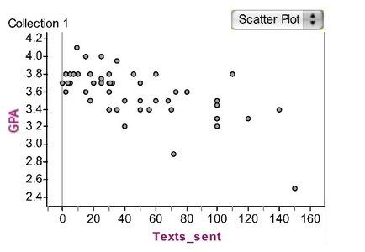

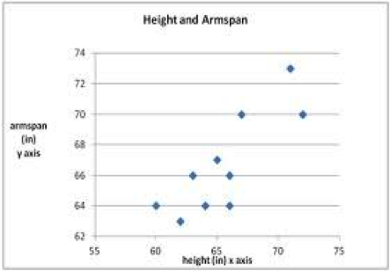

Height

Arm

Span

Arm

Span

Relationship(s): Relationship(s):

3. Number of cats vs. hours spent on HW 4. Value of car by age (how old it is)

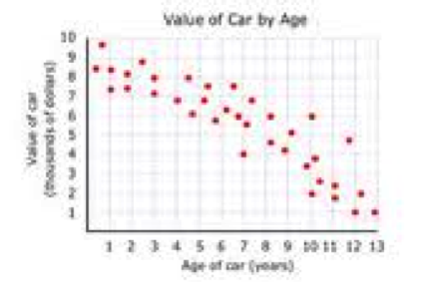

Age of Car

Value

of

Car

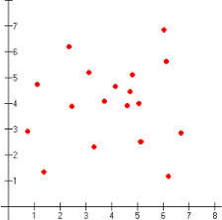

Number of Cats

Hours

spent

on HW

Relationship(s): Relationship(s):

5. Baseball Pitch speed (leaving hand vs. at plate) 6. United Kingdom Population vs. Year

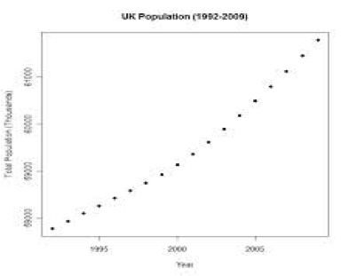

P

o

e

p

l

e

year

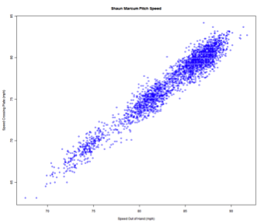

Speed leaving hand

Speed

at

Plate

**Part 2:** Understanding “relationships” or “associations”

After hearing each scenario, think about your response and then, when prompted by the teacher, hold up 1 finger to vote for *positive”*, hold up 2 fingers to vote for “*negative”* and hold up 3 fingers to vote for “*no”* association.

Then, once the class has voted, when asked by your teacher, show a “thumbs-up” if the association is *strong*, a thumbs down if the association is *weak* and a sideways thumb if the association is *neutral* or if you’re not sure.

1. When you consider the amount of time you spend studying and your grades on tests, would you say there is a positive, negative or no association?

2. When you think about the temperature outside and the number of people who go to the beach, would you say there is a positive, negative or no association?

3. When you think about how much a person exercises and their weight, would you say there is a positive, negative or no association?

4. When you consider how many children are in a family and how many earthquakes in California, would you say there is a positive, negative or no association?

5. When you think about how loudly you yell at a baseball game and the number of runs your favorite team (the Angels!) scores, would you say there is a positive, negative or no association?

6. If you consider the number of employees working at McDonald’s and the amount of time you have to wait for your order, would you say there is a positive, negative or no association?

7. When you think about the number of employees working at McDonald’s and the number of pets they each have, would you say there is a positive, negative or no association?

8. When considering the number of days in rains and your shoe size, would you say there is a positive, negative or no association?

**Part 3:**  Looking at the original graphs from Part 1, decide which words from SET 1 describe each graph below and WRITE the words under the graph. If you chose *Positive OR Negative Association,* then choose words from SET 2 that also describe the relationship.

**Word Choices- Set 1:** Positive Association Negative Association No Association

**Word Choices- Set 1:** Strong Weak Linear Relationship Non-Linear Relationship

1. Height vs. Arm Span 2. Text Messages sent vs. GPA (grades)





Height

Arm

Span

Relationship(s): Relationship(s):

3. Number of cats vs. hours spent on HW 4. Value of car by age (how old it is)



Age of Car

Value

of

Car



Number of Cats

Hours

spent

on HW

Relationship(s): Relationship(s):

5. Baseball Pitch speed (leaving hand vs. at plate) 6. United Kingdom Population vs. Year



P

o

e

p

l

e

year



Speed leaving hand

Speed

at

Plate

**Part 4: Definitions for describing relationships with Bivariate Data**

**Positive Association:** A relationship between two quantities where one quantity increase while the other also increases.

**Negative Association:** A relationship between two quantities where the dependent variable (represented on the y-axis) decreases while the independent variable increase.

**No Association:** As one variable increases, there is no effect on the second variable.

**Strong Association:** This could be either positive or negative, but the points represented by the two variables are all very close to a straight or curved line that could be drawn through them.

**Weak Association:** This could be either positive or negative, but the points are farther from a straight or curved line that could be drawn through them.

**Linear Relationship:** The points are somewhat close to a line that could be drawn through them

**Non-Linear Relationship:** The points are somewhat close to a curved line that could be drawn through them.

**Teacher Directions**

**Part 1:** Pass out the activity sheet to each student and have them read the directions. Quiz a few students to ensure they understand the directions. Then, set the timer for 10 minutes to allow them to “study”, silently, the graphs and record (or keep in their mind) what relationship(s) they see between the two variables. (They should have prior knowledge of this from interpreting graphs of linear functions in the prior unit). After 10 minutes, number off the class into 1’s and 2’s. Using inside-outside line, have the 1’s form a line (with their activity sheet) facing the 2’s. Have the 1’s explain what they saw in graph 1 for 30 seconds and then have the 2’s add their thoughts on graph 1. Then have the 2’s share what they saw in graph 2 for 30 seconds and then have the 1’s reply with their thoughts. Have all 1’s take a step to their right (and student on end go to other end) and repeat this for graphs 1 and 2. Have the 1’s move again and now repeat for graphs 3 and 4. Have the 1’s move again and repeat one more time for graphs 3 & 4. Have the 1’s move again and repeat the process for graphs 5 & 6. Do one last round for # 1’s and repeat for graphs 5 & 6. Have students return to their seats and call on a student, at random, to explain what relationship(s) he/she saw in a graph and repeat this so that 1 persons shares for each graph.

*Alternative to inside outside line: In groups of 4, use Roundtable where the person who is the youngest shares one idea about graph one and then the group rotates sharing about graph 1 in a circle until they get back to the first person. Repeat this process for the remaining 5 graphs.

**Part 2:** Read each scenario aloud. After 20 seconds of silent think time, have each student turn to their elbow partner to discuss for 20 seconds. Then, ask each student to hold up finger to vote: hold up 1 finger to vote for *positive”*, hold up 2 fingers to vote for “*negative”* and hold up 3 fingers to vote for “*no”* association.

Call on a few students to explain their thinking.

Then, once the class agrees (or at least agrees to disagree), ask each student to think about if the association is strong, weak, or neutral. Then ask them to vote again, using a “thumbs-up” if the association is *strong*, a thumbs down if the association is *weak* and a sideways thumb if the association is *neutral* or if you’re not sure.

Again, call on a few students to share their thinking.

**Part 3:** Have the students, independently, go back to the first 6 graphs which are now copied again on page 3. Have them write (under each one) the academic vocabulary they think matches the data displayed. After 5 minutes alone, give them 5 minutes to work with an elbow partner and then call on students at random to share which labels they attached.

**Part 5:** Close this lesson out by going over the definitions on page 4. After students read, show a graph from Task 3 and ask which word(s) they would use to describe to relationship between the two variable. Note that the academic vocabulary is introduced AFTERT they have experience and conceptual understanding.