Which Container Should I Build?
Name:____________________________________ Date:__________ Period:_______
Background: You are going to design a container to use to sell a drink you just invented. You want the shape to be unique, but you also want it to be able to hold enough of the drink to make the price reasonable. You narrow down your choices to the following four shapes: Cube, Cylinder, Cone and Sphere (See pictures below). Before you decide, you need to compare how much of the drink each container will hold. Below the name of each shape are its dimensions.
Sphere
8cm Diameter
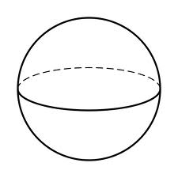
Cylinder
8cm diameter; 8cm height
Cone
8 cm diameter; 8 cm internal height (altitude)
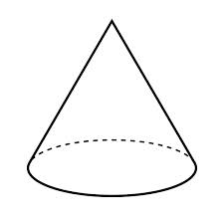
Cube

Predict: Write the names of the shapes in order from which will hold the least liquid to which will hold the most.

1. _______________ 2. ________________ 3.________________ 4._____________

Step 1: Build a model of each container from Play-doh. Note: Consider using a toothpick 8cm long to verify your solid is accurate.

Step 2: Revise your prediction.
Now that you can see the containers, predict, again, which container will hold the most liquid. Record the predicted order below from least to greatest.

1. _______________ 2. ________________ 3.________________ 4._____________

Step 3: Weigh to verify
As all of the containers are made from the same play-doh with the same density, we can weigh them to measure mass which will give us some good data about which container will hold the most and least liquid. Record the weight of each solid and list them in order from least to greatest volume.

1. Shape: _________________, Mass:________

2. Shape: _________________, Mass: ________

3. Shape: _________________, Mass: ________

4. Shape: _________________, Mass: ________

Step 4: Analysis
1. What, if anything, surprised you about the results?

________________________________________________________________________

________________________________________________________________________

2. Knowing how much liquid a similar size container in each shape will hold, which container would you use and why?

________________________________________________________________________

________________________________________________________________________
Teacher Directions
Materials:
Play-doh (1 container per person)
Skewer longer than 8cm and marked at 8cm (1 per person)
Scale (minimum of 1 per class)
Cube, Cylinder, Cone and Sphere (for class demonstration)

Directions:
Show the students a few examples of containers to hold drinks (see below for some options). If time permits, give students a few minutes to think about what type of drink they would create if they were allowed to mix or make any flavor.
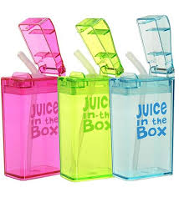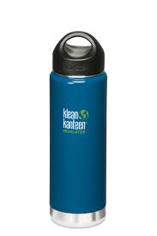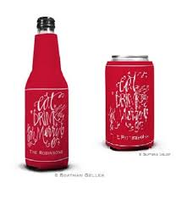

Pass out the activity sheet and have a student read the “background” aloud. Have the students look at the pictures of the four container options and do a think-pair-share to discuss which container they would choose and why. Then direct the students’ attention to the “prediction” section. Give the students 90 seconds to think and record their prediction (note: allow students to predict some as having equal volume if they so desire). Put the class into groups of 4. Have the class read the directions for Step 1 and question the class to make sure they understand what to do and what the measurements mean from the picture (make sure they know that the “height” for the cone is from the center of the circle up through the top vertex of the cone, that the diameter of the sphere is across the middle and where the height of the cylinder is).

Pass out a container of play-doh and a skewer marked at 8 CM to each student. Each group of 4 needs to build each solid accurately. Once the solids are built, have each student in each group revise their prediction (or write down the original if they think it is still correct).

Once a group shows you their 4 solids and revised predictions, allow them to weigh their four solids and have them complete Step 3. Note: The order will be Cone, Sphere, Cylinder and hen Cube (Least to Greatest).

Finally, have each group complete the analysis questions and then lead a class discussion about question #1- which shapes have greater and less volume. Note: students will officially explore the relationships between the volume of cones and spheres compared with cylinders and cubes later in this unit. Have the class use roundtable to discuss the final question.

