**Will the Candy Fit?**

Name: _________________________________________________ Date: _______________ Period: _________

Opening Question

You just got a sphere of small candies (see picture below). You dropped the “ball” and it has cracked open. For safe-keeping, you decide to transfer the candies into another container. You have a cylindrical can whose height and diameter are equal to the diameter of the sphere.

1. Will the candies fit? ________________

2. Will there be extra space in the cylinder? ______________ If so, about how much? __________

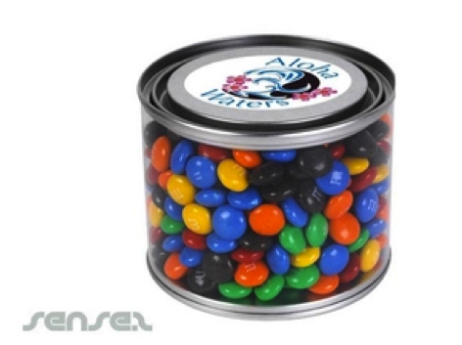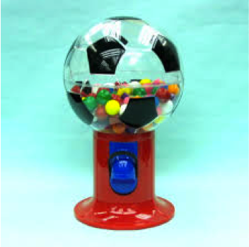

Spherical Container- Not Drawn to Scale

Cylindrical Container- Not Drawn to scale

Recall

1. Which container had a greater volume (from the play-doh activity), a Cylinder with a radius of 4 cm or a sphere with a radius of 4 cm? ________________________________

Test

1. Fill the sphere with beans.

2. Pour those beans into the cylinder. Are the volumes equal?_______________

3. Using the table below, shade the portion of the cylinder that is filled from one sphere.

4. Fill a second sphere. Pour these contents into the cylinder, using an additional cylinder if necessary.

5. Shade the portions of the cylinder(s) that are filled by the two spheres.

6. Continue filling the sphere and pouring it into the cylinder until you have FULL cylinders. Record the results in the table after each fill and pour. (Draw more, if needed)

|  |  |
| --- | --- |
| Number of Filled Spheres | Number and Portion of Filled Cylinders |
| 512px-Sphere.svg.png512px-Sphere.svg.png1. | images-1.jpeg |
| 512px-Sphere.svg.png512px-Sphere.svg.png2. | images-1.jpegimages-1.jpeg= |
| 512px-Sphere.svg.png512px-Sphere.svg.png512px-Sphere.svg.png3. | images-1.jpegimages-1.jpeg |

Reflect

1. So, is the volume of a sphere equal to the volume of a cylinder with the same radius and same height? Why or why not?

_______________________________________________________________________________________________________

2. How many spheres “fit” into how many cylinders? ________________________________________

3. So, what fraction of the volume of the cylinder was the volume of the sphere? _________

4. Let’s calculate the formula for the volume of a sphere.

a. Write the formula for the volume of a Cylinder. ________________________

b. Using the pictures below to help you, label the radius of the cylinder and the height of the cylinder in terms of *r*.

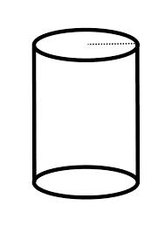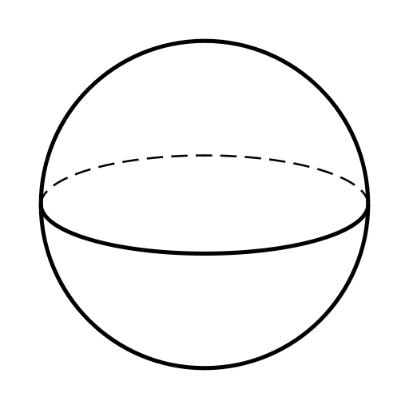

*r*

*r*

*r*

c. Calculate the volume of the cylinder above (using *r*).

V=

d. Apply what you found in #3 (the fraction of the cylinder the volume of the sphere represents) to the volume of the cylinder you just found in “c” above and record the formula in the box below.

Volume of a Sphere Formula:

5. So, will the candy fit? ___________ How much extra “space” will there be? _____________

**Teacher Directions**

**Materials:**

* Beans (or rice or water) (enough to fill 2 cylinders)
* Plastic Sphere (with hole for filling)- 1 per group
* Plastic Cylinder with radius equal to sphere and height equal to the diameter of the sphere (with hole for filling) - 1 per group

Opening

Show the pictures of the candy containers on the document camera and have a student read the scenario aloud. While students think silently, pass out the activity sheet and have them record their thoughts. Select a few students to share ideas.

Recall

Give students one minute to silently think about the play-doh activity and record their answer. Take a quick class vote- thumbs up for cylinder holding more; thumbs down for sphere holding more and sideways thumb for equal volumes.

Test

Direct the students’ attention to the table at the bottom of page 1. Explain that they will fill spheres with beans and pour them into cylinders, and they need to shade the total number of spheres and total number/fraction of the cylinders filled with each pouring of the sphere. Note: For one sphere, the cylinder should be about  full. For two spheres, there should be about  cylinders filled, and for three spheres, there should be two full cylinders. If students don’t get this, they can continue pouring to get a multiple of the 3:2 relationship.

Once students understand, have the materials manager from each group come get the sphere, cylinder and beans. Encourage students to be precise in their shading of the cylinder.

Reflect

Once a group completes the investigation, have each student answer reflection questions 1-3 on their own. (Note, students who struggle with fractions may struggle with #3 and need some guidance). For groups doing well, allow them to continue through the rest of the questions. Is the class struggles, go through #4 together. Here is the math for # 4c:



4d- The volume of the sphere would be  of the cylinder, so the formula should be 

Finally, have the students answer reflection question #5.