1. Consider the differential equation , where .
   1. On the axes provided, sketch a slope field for the eight points indicated.  
       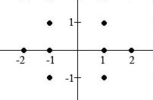
   2. Find the particular solution  to the differential equation with the initial condition  and state its domain.
2. Consider the differential equation .
   1. On the axes provided, sketch a slope field for the nine points indicated.  
       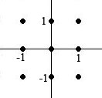
   2. There is a horizontal line with equation  that satisfies this differential equation. Find the value of *c*.
   3. Find the particular solution  to the differential equation with the initial condition .
3. Consider the differential equation , where .
   1. On the axes provided, sketch a slope field for the nine points indicated.  
       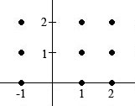
   2. Find the particular solution  to the differential equation with the initial condition .
   3. For the particular solution  described in part b, find .