Sets of Numbers
Imaginary (or Complex) Numbers: Has i (which = ) in it
Real Numbers: Everything except imaginary
Irrational Numbers: Non-terminating, non-repeating decimals like π, e, or
Rational Numbers: Can be written as a fraction
Integers: All whole numbers (including zero and negatives)
Natural Numbers: Positive whole numbers
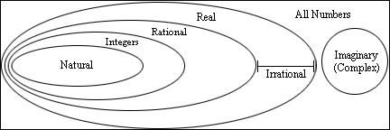

Interval Notation
An interval is a piece of the number line (like all numbers between 2 and 5)
Write it as the two endpoints separated by a comma in parentheses
For a , use square parentheses. For a < or >, use regular parentheses
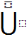 = union (combination of two intervals)
= intersection (overlap of two intervals)
Write in interval notation:

Distance Formula  To find the length of a segment using its endpoints  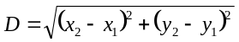 | Midpoint Formula  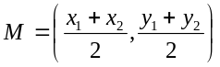

Find the distance between the points (5,-1) and (-2,7). Then find the midpoint.

Factoring
To solve an equation by factoring, it must be equal to zero!!!
Some common factoring patterns to know:

Solve for x: | Factor and simplify:

Slope
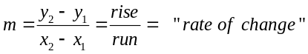
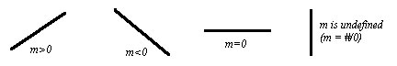
Lines
Slope-intercept form: y = mx + b
Point-Slope form: (y – y₁) = m(x – x₁)
Standard form: Ax + By = C (A, B and C are non-zero whole numbers)
Vertical line: x = constant
Horizontal line: y = constant
Parallel Lines: m₁ = m₂
Perpendicular Lines: 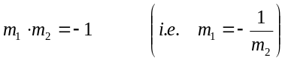

Find the equation of the line with a slope of -3 that passes through the point (-2, 5)

Intercepts
To find an intercept of any graph, set all other variables equal to zero and solve for the remaining variable

Find the x-intercept(s) of the graph of

Find the y-intercept

Functions
Function: An equation that relates 2 variables where each input has exactly one output (“vertical line test” says that if a vertical line crosses a graph more than once, then it is not a function)
Domain: Any x that can be put into the function and give a valid output (remember, the easiest way to find domain is you ask yourself what x can not be)
: All Real numbers =
: The empty set (nothing)
: “The set of all real numbers x, such that x is less than or equal to 5”
Range: All the values that f(x) takes on.
The easiest way to find range is using a graph. Look for a “floor” or “ceiling” the graph doesn’t pass

Find the domain of

Use a calculator to find the range

Find the domain of 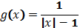

Find the domain of 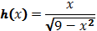

Function Notation: x is the input, and f(x) is the output (basically, f(x) is y)

For , find 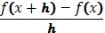. (Note: this is called the difference quotient, and is important)

Restricting Domain
Sometimes you only want to look at a piece of a function. You can do this just by telling the reader what x can be.
For example:
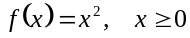
Would be the right side of a parabola

Write an equation for the graph of the line segment that connects the points (2,5) and (-7,1).

Piecewise Functions
A function with more than one equation.
Each equation is used over a separate interval (just like restricting domain)

If 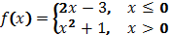

Absolute Value
|x| is the distance from zero to a number x on a number line (direction doesn’t matter)
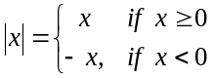
Solve for x:

Express as a piecewise function

Graphing
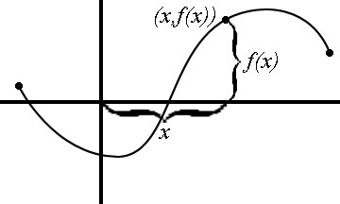 | x is the horizontal component (distance right or left)  f(x) is the vertical component (height) at x
Library of functions:
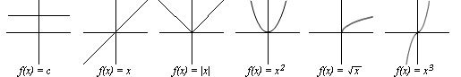

Transformations
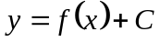 shift up if C is positive, down if C is negative
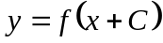 shift left if C is positive, right if C is negative

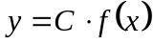 stretch ↕ by a factor of C
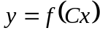 stretch ↔ by a factor of C
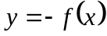 reflect about the x-axis
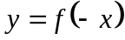 reflect about the y-axis
* reflect and stretch before you shift!

Even Function: f(-x) = f(x) and the graph is symmetric about the y-axis
Odd Function: f(-x) = -f(x) and the graph is symmetric about the origin (180º rotation)
Note: cos is even, while sin and tan or odd. Reciprocals are the same.
Increasing: If x₁ > x₂, then f(x₁) > f(x₂) (“Rising” over a certain interval)
Decreasing: If x₁ > x₂, then f(x₁) < f(x₂) (“Falling” over a certain interval)
Constant: For any x₁, x₂, f(x₁) = f(x₂) (“Flat” over a certain interval)

Is each function even, odd or neither?

Use the graph below to answer the questions.  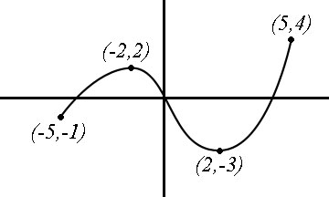 | 1. Does the graph represent a function?  2. If so, what is its domain?  3. If so, what is its range?  4. On what interval(s) is the graph increasing?  5. When x = -2, what is f(x)?  6. For what value(s) of x does f(x) = -3?  7. Draw f(x + 2) on the graph above

Compositions:
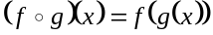
Note: To find the domain of f(g(x)) you must also consider the domain of g (the second function)

Find the domain of if 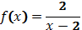 and

Find the domain of

Inverses
* To find a functions inverse, switch x and y, and solve for the new y.
Notation: 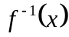
Definition: 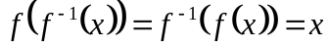
Graphs of inverse functions are reflections of each other in the line y = x
Important note:
Domain of 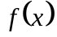= Range of
Range of = Domain of

If , find

If

Properties of Exponents
 | 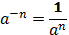 | 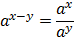
True or false: 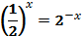

Evaluate:

Logarithms
is read “log base 5 of x” and means “5 to what power equals x?”
b can be any positive number except 1
You can not take the log of a negative number or zero (domain is x > 0)
Logs and exponentials are inverses!
Properties of Logarithms (For any b > 0)
- 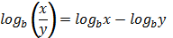
- 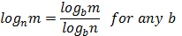
Converting logs to exponentials
Method 1 – Definition of inverses  Just switch x and y | Method 2 – Canceling out functions  Use property 3 or 4 above

Convert:

Find the domain of:

Solving Log/Exp Equations
Isolate the log/exp function
Switch forms using one of the methods above
Solve for x
Check your answers (extraneous solutions for log solutions)

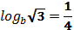

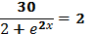

Trigonometry
Know the unit circle!!!! I’m not going to re-re-re-re-teach it.
Know radian angles (2π = 360º)
Know Identities: Reciprocal, Pythagorean, Even/Odd

Evaluate:  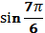  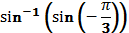  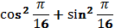 | 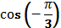  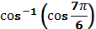

Solving Trig Equations
Isolate the trig function(s) first (often done by factoring)
Solve using inverse trig (unit circle)

