Using a clinometer, find the angle of elevation for each of the following objects. Since the top number on our protractors is 90 degrees (not 0 like in the diagram), be sure to use COMPLEMENT of the ACUTE angle you find on the clinometer.

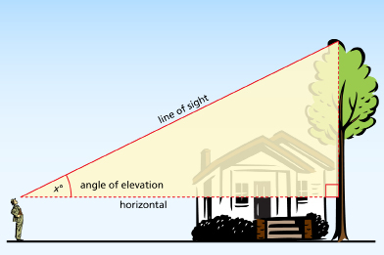
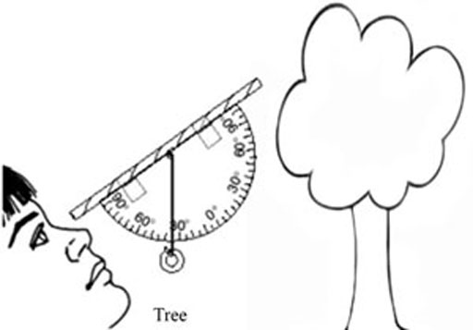

Flagpole: Stand by the staked tree near the front parking lot. The tree is outside the gate closest to the Health Office.

Angle of elevation:

Top of Forum: Stand by the new “Class Theme” plaques which are mounted on the west side of the block wall in the middle of the quad. Sight the top of the bricks of the Forum – use the nearest of the 2 portions of brick that stick out from the building.

Angle of elevation:

Tree behind flagpole: Stand in front of the pile of rocks in the middle of the quad (at the end of the block wall). Sight the highest point on the north side of the tree behind the flagpole.

Angle of elevation:

Tree behind apartments north of campus: Stand in front of the rock outside Room 901. Sight the top of the tree behind the apartment complex across the field. You are looking for the eastern-most tree you can see – it should be visible just to the right of Room 901.

Angle of elevation:

Light tower at Handel Stadium: Stand in front of the rock outside Room 901 (the same location as the previous measurement). Sight the top of the light tower that is visible over Rooms 902 and 903.

Angle of elevation:

